Artificial Intelligence

Name: J. Anisha Jenifer
Reg No: 192511004
Course: CSA1718 Artificial Intelligence

Experiment 7: Depth First Search (DFS)

Aim
Aim: To implement Depth First Search (DFS) traversal using Python.

Algorithm
1.Create the graph.
2.Mark start node as visited.
3Visit the node.
4.Recursively visit each unvisited neighbour.
Stop when all nodes are visited.

Pseudo Code

START
Create graph
Mark node as visited
Display node
FOR each neighbour
IF not visited
Call DFS(neighbour)
STOP

Program
graph = {
'A': ['B', 'C'],
'B': ['D', 'E'],
'C': ['F'],
'D': [],
'E': ['F'],
'F': []
}
def dfs(graph, node, visited):
if node not in visited:
print(node, end=" ")
visited.add(node)
for neighbor in graph[node]:
dfs(graph, neighbor, visited)
visited = set()
dfs(graph, 'A', visited)

Sample Output
A B D E F C

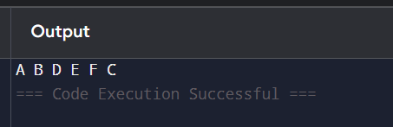

Experiment 8: Travelling Salesman Problem

Aim: Find minimum tour using brute force.

Algorithm
1. Read graph.
2. Generate tours.
3. Find minimum cost.
4. Print route.

Pseudo Code
Start
Generate permutations
Compute cost
Print minimum
Stop

Python Program
from itertools import permutations

g = [
[0, 10, 15, 20],
[10, 0, 35, 25],
[15, 35, 0, 30],
[20, 25, 30, 0]
]

n = 4
ans = 10**9

for p in permutations(range(1, n)):
cost = 0
k = 0

for j in p:
cost += g[k][j]
k = j

cost += g[k][0]
ans = min(ans, cost)

print("Minimum Cost:", ans)Input
Graph matrix

Output
Minimum Cost: 80

